 Britannica Kids

Britannica Kids

https://kids.britannica.com › students › article › ballet

How do you explain ballet to a child?

Ballet is a theatrical form of dance with a long history. It creatively expresses the full range of human emotions through physical movements and gestures. Most ballets tell a story, using mime, music, costumes, and scenery to reinforce the dramatic feeling.

What makes ballet unique?

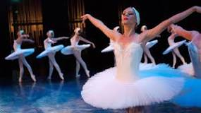

Classical ballet is: Built on a specific set of body positions and movements designed to make the dancer appear graceful and elegant. Characterized by "turn-out." Ballet dancers rotate their legs outward from their hips to allow a greater range of movement.

What does ballet teach us?

Ballet teaches valuable life lessons that extend beyond the dance studio. Through discipline, perseverance, teamwork, confidence, body awareness, attention to detail, self-expression, and patience, dancers can utilise these skills in other aspects of their life.

What is the main purpose of ballet?

With no definite story line, its purpose is to use movement to express the music and to illuminate human emotion and endeavor. Today, ballet is multi-faceted. Classical forms, traditional stories and contemporary choreographic innovations intertwine to produce the character of modern ballet.

What is the moral lesson of ballet?

Ballet teaches the importance of adapting and growing, not just as a dancer, but as a person. Dancers learn to evolve with the art form, embrace new challenges, and continually refine their craft.

Why do people love ballet?

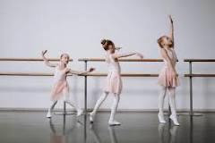

Ballet allows us to let go of everyday struggles and enjoy the freedom of motion and sound - almost like an unspoken truce with ourselves and those around us. Being able to freely express our emotions, feelings and thoughts allows us to live joyous, lighter and fuller lives.

What does ballet teach a person?

Ballet teaches strength, coordination, and flexibility. Ballet helps the body to be strong and limber, and it helps with mobility and posture. Ballet is also a great cardiovascular activity as it can elevate the heart rate and can promote healthy physical activity.

What are the emotional benefits of ballet?

Ballet can also have overall mental health benefits. Research has shown that participating in dance classes can help reduce stress, anxiety, and depression. Ballet can provide a healthy outlet for children to express themselves creatively while also improving their mental and emotional well-being.

Can ballet tell a story?

The ability to tell a story and how emotion without words is known as "classical mime", which plays an important role in ballet. Narrative ballets are essential to a ballet company's repertoire, because they tend to generate the highest sales and bring families with children to see the ballet.

What does ballet teach you in life?

Ballet teaches valuable life lessons that extend beyond the dance studio. Through discipline, perseverance, teamwork, confidence, body awareness, attention to detail, self-expression, and patience, dancers can utilize these skills in other aspects of their life.

For more information about ballet:

Another link to more information about ballet for kids from: http://kids.kiddle.com

Ballet Facts for Kids

Another link to more information about ballet for kids from: https://kids.britannica.com

ballet - Students